Project Design Phase-Technology Stack (Architecture & Stack)

|  |  |
| --- | --- |
| Date | 03 October 2022 |
| Team ID | 592350 |
| Project Name | Deep Learning Model for Eye Disease Prediction |
| Maximum Marks | 4 Marks |

Technical Architecture:

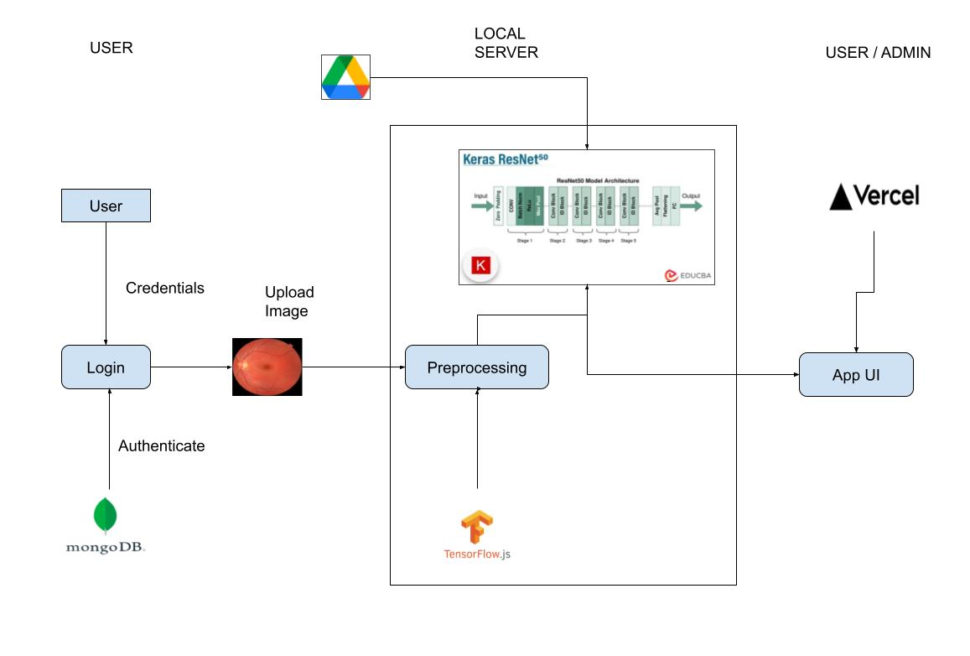

Table-1 : Components & Technologies:

|  |  |  |  |
| --- | --- | --- | --- |
| **S.No** | **Component** | **Description** | **Technology** |
| 1. | User Interface | How user interacts with application e.g. Web UI, Mobile App, Chatbot etc. | HTML, CSS, ReactJS |
| 2. | Exporting Model | Saving and then converting the TF model into h5 format and then converting it into Graph Model suitable for JS. | TensorFlow, TensorFlowJS |
| 3. | Preprocessing | Preprocessing the images uploaded by user for classification | TensorFlowJS |
| 5. | Database | Data Type, Configurations etc. | NoSQL (MongoDB) |
| 7. | File Storage | File storage requirements | Google Drive, Local Filesystem |
| 8. | API-1 | User Login and Registration | Backend Server |
| 9. | API-2 | CRUD Operations | Backend Server |
| 10. | Machine Learning Model | Classification of fundus images | ResNet-50 Model |
| 11. | Infrastructure (Server/ Frontend) | Application Deployment on Cloud | Render , Vercel |

Table-2: Application Characteristics:

|  |  |  |  |
| --- | --- | --- | --- |
| **S.No** | **Characteristics** | **Description** | **Technology** |
| 1. | Open-Source Frameworks | OWASP provides a variety of resources, including libraries, documentation, and tools, to help developers build secure web applications. Notable projects include the OWASP Web Application Firewall (OWTF), OWASP ZAP (Zed Attack Proxy), and the OWASP Application Security Verification Standard (ASVS).CORS Anywhere is a Node.js proxy server that adds CORS headers to a request. It can be useful for testing and development to bypass CORS restrictions. | OWASP, CORS |
| 2. | Security Implementations | Cross-Site Request Forgery (CSRF) Protection,  Cross-Origin Resource Sharing (CORS),  API Security, Authentication and Authorization: | e.g. SHA-256, Encryptions, IAM Controls, OWASP etc. |
| 3. | Performance | Technologies like Node.js and libraries like Async/Await enable non-blocking, asynchronous operations, which can improve responsiveness in web applications | Asynchronous Programming |